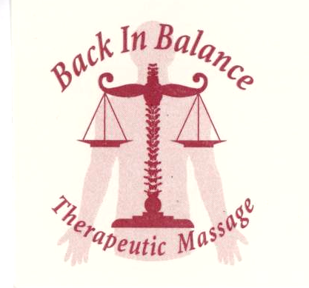
Gift Certificate
2223 West State Street Suite 111 Olean, NY 14760 716-307-3943

To:___________________________
From:_________________________
Entitles You To:_________________
Issued By:______________________
Expires:________________________
Authorization Code:______________
Please call Jodie at 716-307-3943 to schedule your appointment. Please let Jodie know that you have a gift certificate and give her the authorization code.

Directions for using gift certificate online. Call Jodie at 716-307-3943 to make payment arrangements. Once payment is received, you will be given an authorization code. This gift certificate is not valid without proper authorization code.

